1. Open a command prompt as an administrator, and execute mmc.exe. Under File, select Add/Remove Snap-in, select certificates, and click the add button

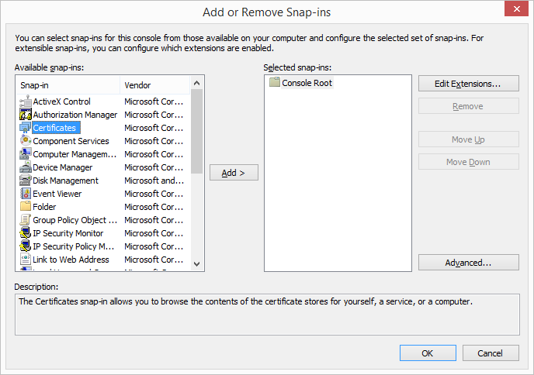

1. Select computer account, and click next

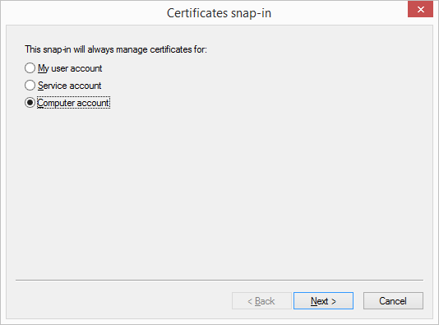

1. Leave it on local computer, and click finish

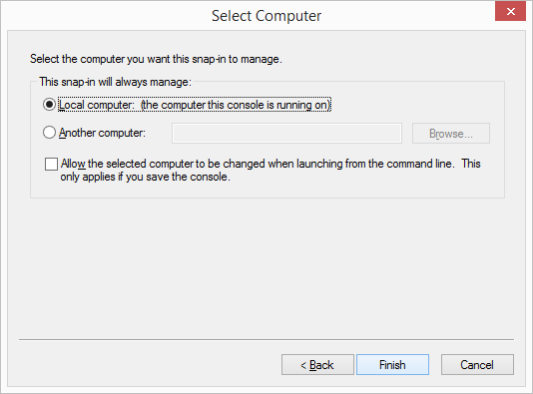

1. Click OK

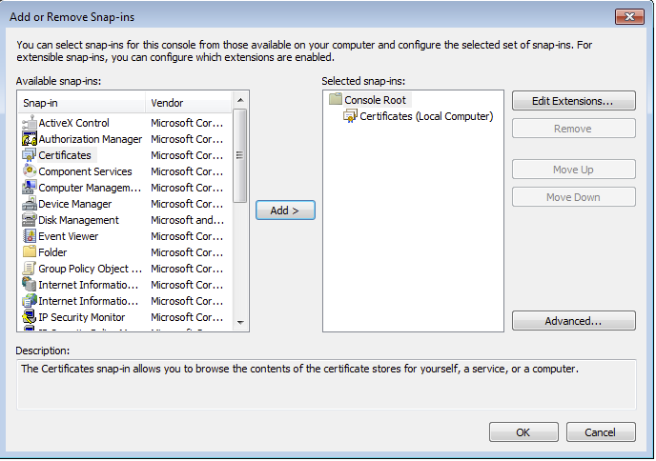

1. Expand Local Computer and select Personal, Certificates. Right click, select All Tasks, Import.

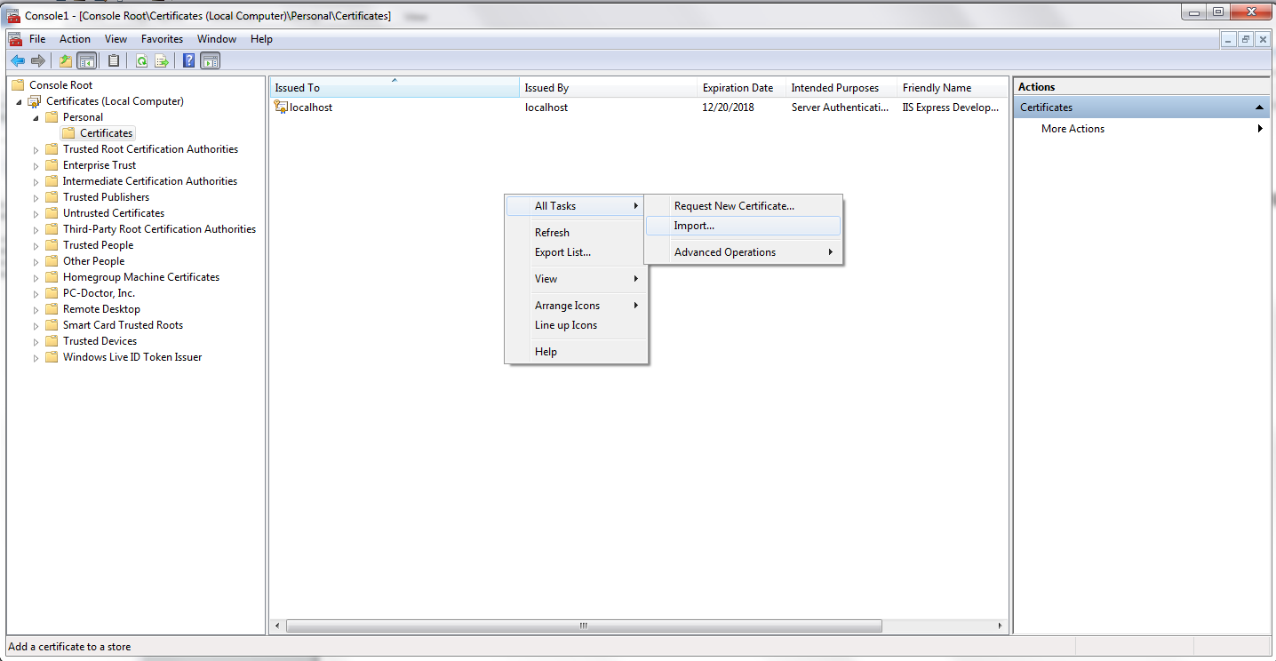

1. Click next

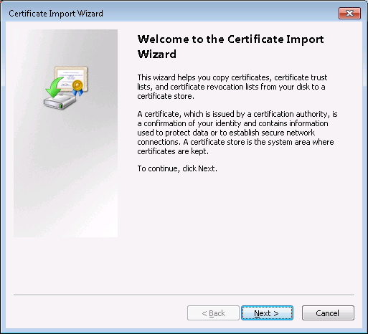

1. Specify the Parature pfx certificate from the Certificate Authority

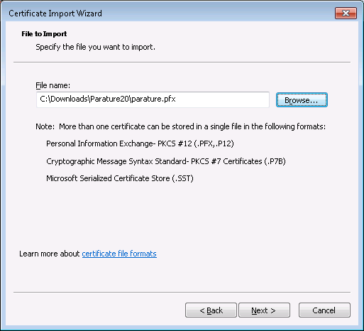

1. Enter the password, select Mark this key as exportable

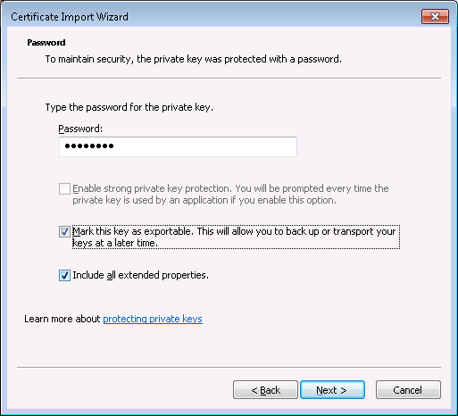

1. Leave it on Personal store, and click next

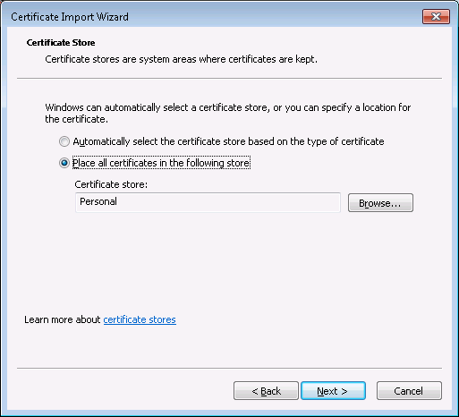

1. Click finish

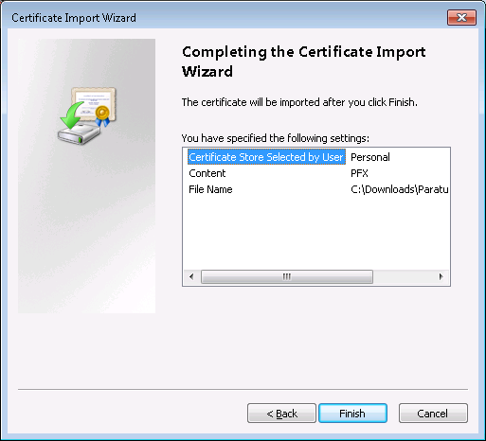

1. Right click on the Parature certificate, and select All Tasks, Export

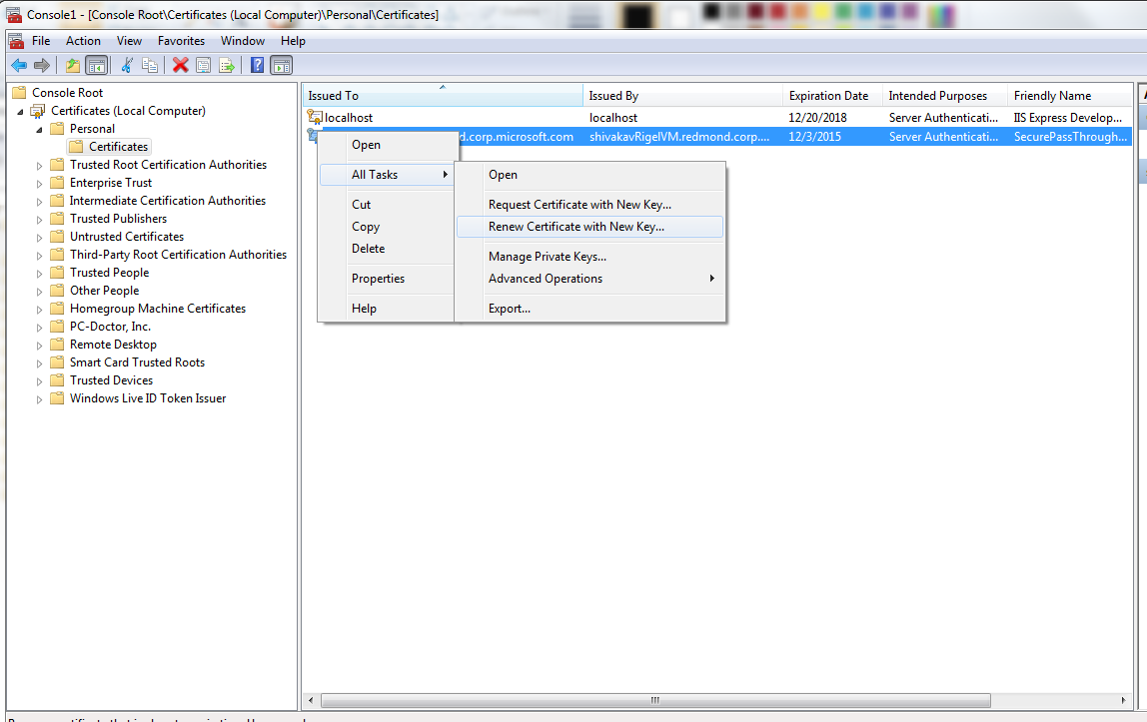

1. Click next

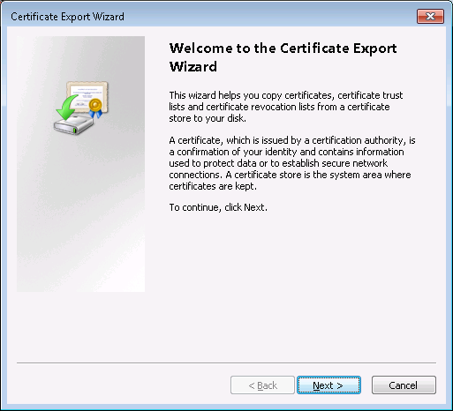

1. Select Yes, export the private key, and click next

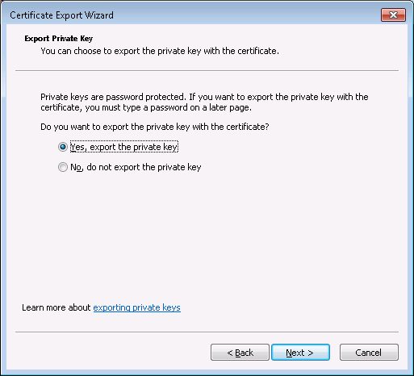

1. Click Include all certificates in the certificate path if possible, and click next

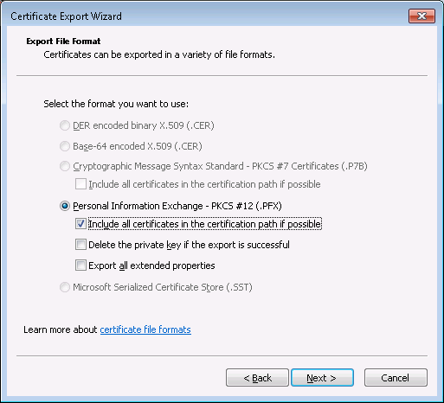

1. Enter the password, and click next

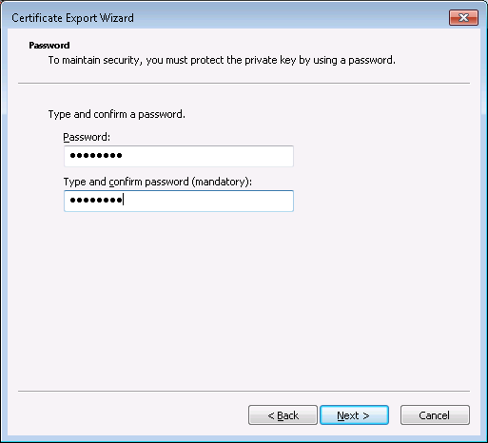

1. Enter the new certificate filename, and click next

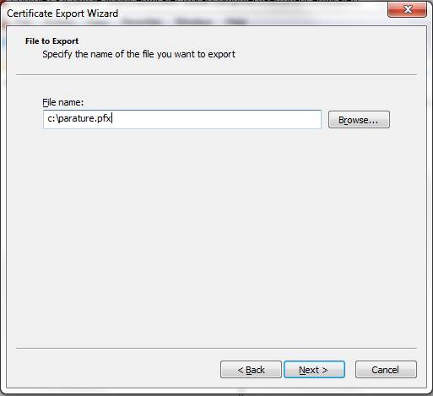

1. Click finish

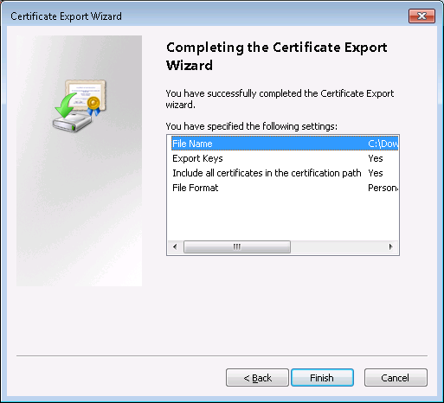

1. Open a command prompt as an administrator, and execute openssl

C:\ >openssl pkcs12 -in parature.pfx -out parature.pem -nodes

C:\ >openssl pkcs12 -export -out parature.pkcs -in parature.pem